**Computer Programming 1  
Indicator Apply Operators and Boolean Expressions. (3%)**

In all programs, put your name, the assignment name and the date in comments at the top.  
Reminder, put an apostrophe (‘) in front of your line to make it a comment.

1. Create a new project called Math
   1. Add the controls shown on the form below. Name them appropriately  
      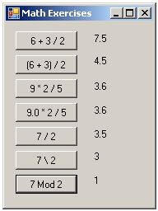
   2. Using formulas, display the answers for each equation in a label in the button clicks.
2. Create a new project called Mints
   1. Add the following controls (You can use 2 or 4 labels for the answers)  
      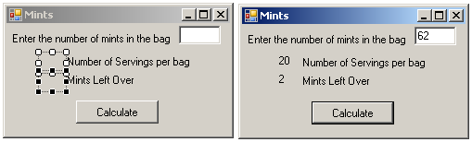
3. For the btnShowMints control, create a Click event.
   * 1. Declare variables needed for input and output
        + Total number of mints, Servings per bag and Mints LeftOver
        + Students eat 3 mints per serving
     2. Get the input from your textbox using the Convert method to convert to an Int32 (Integer)
     3. Calculate the servings and mints left over using Integer and Modulus division
     4. Display the answer in your answer labels.
        + Don’t forget to use ToString